How to get PC400 along with CRBasic Editor

Note: CRBasic for CR300 syntax and language help at: <https://help.campbellsci.com/crbasic/cr300/>

To get PC400 all you have to do is go to the Campbell Scientific website and search for the software. But first, you’ll have to create an account. If using UPRM’s email make sure check it, as Campbell Scientific has some contract with the university that may restrict your access to some places in the website. The file to download is about 140MB of size.

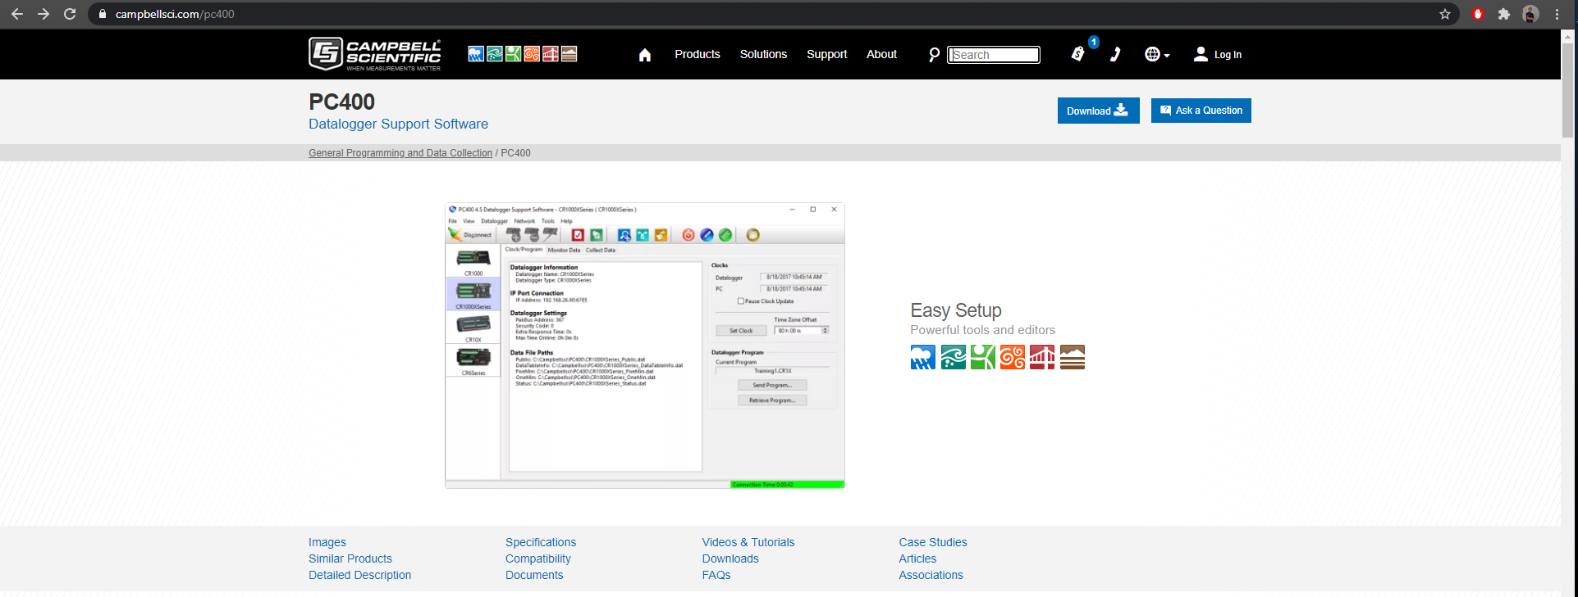If already logged in, the go to the upper right corner of the site where there is a button to download the program. It then should begin to download.

After downloading, just open the file and follow the installation instructions. If having problems with accessing the program due to a license, **check the email** used for the license key.

How to use PC400 along with CRBasic Editor

When you have the program installed and opened, there will be a taskbar with different functions. The two main functions the team used are the Connect and CRBasic Editor buttons (which are identified with red circles). The connect button is to connect the Datalogger to the computer, while the CRBasic Editor button opens a new window that runs the editor. In the editor you have access to the documentation of the functions of the program and is able to compile your code.

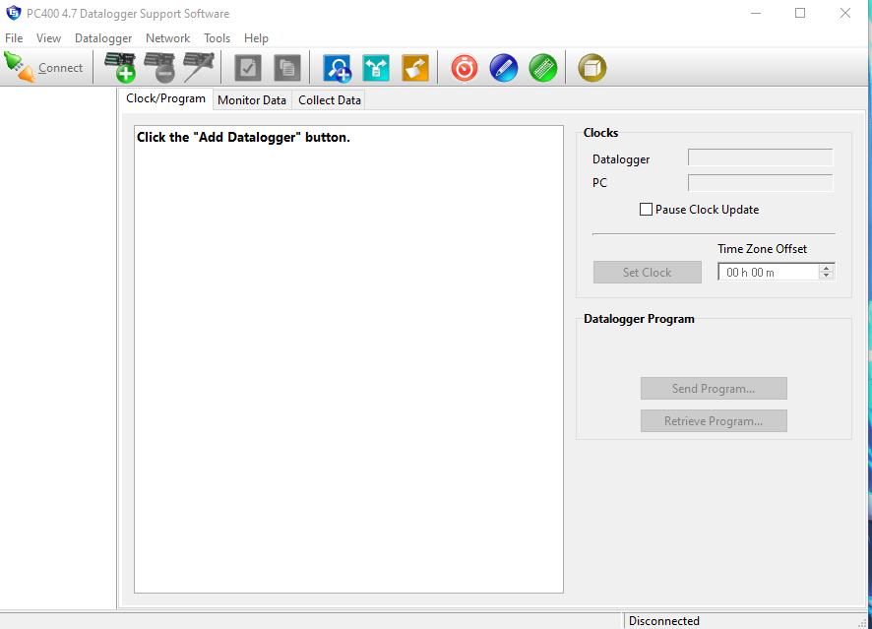

Lastly the Send Program button is to send a program to the Datalogger so that it runs it. This is what is used to give the autonomous software to the boat.

Hope this helps! -FM